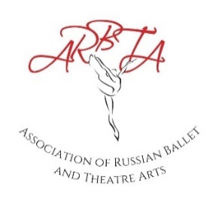
ASSOCIATION OF RUSSIAN BALLET & THEATRE ARTS
EXAMINATION PAYMENT FORM Indian Rupee (from January 2023)

The fees below state the basic rate for examinations from January 2023. A
supplement may be applied to the examination fees depending on the location of the examination session and the number of entries.
Name of School:
Date of Examinations:
Ballet and Contemporary Examinations |  |  |  | Jazz, Tap & Character Awards
Level | Amount  Indian Rupee | Total Candidates  Entered for Level | Total Amount | Level | Amount | Total Candidates  Entered for Level | Total Amount
Preliminary Assessment | 4500 |  |  | Assessment Class | 4500
Preliminary Examination | 4600 |  |  | Preliminary | 5100
Grade 1 | 5000 |  |  | Junior Bronze | 5200
Grade 2 | 5100 |  |  | Junior Silver | 5300
Grade 3 | 5200 |  |  | Junior Gold | 5400
Grade 4 | 5500 |  |  | Senior Bronze | 5500
Grade 5 | 5600 |  |  | Senior Silver | 5600
Grade 6 | 5700 |  |  | Senior Gold | 5700
Grade 7 | 5800
Grade 8 | 6000
Intermediate | 7200
Advanced Foundation | 7500
Advanced I | 7700
Advanced II | 8000
 |  | Total  Sum |  |  |  | Total Sum
Total Sum Examinations and Awards

Teachers Examinations (Ballet/Jazz/Tap/Contemporary/Character)
Level |  | Amount | Total Candidates Entered for Level | Total Amount  (Amount x Total Candidates)
Associate - All 4 Modules |  | 36,000
Associate - Singular Module |  | 10,000
Diploma - All 4 Module |  | 37,000
Diploma - Singular Module |  | 10,000
Advanced - All Modules |  | 23,500
 |  |  | Total Sum Teachers Exams
Complete Sum – Total Sum of Examinations, Awards and Teachers Examinations
Complete Sum – Total Sum of Examinations, Awards and Teachers Examinations minus £100 deposit
Payment Date:
Please pay the Complete Sum via bank transfer to ARBTA –
Ref: Exams and School Name.
Association of Russian Ballet and Theatre Arts Ltd.
Account no. 10644254 Sort Code. 60-83-71
All forms should be emailed to ad.arbta@gmail.com

