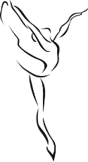
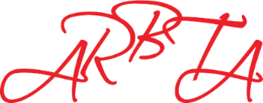
Association of Russian Ballet & Theatre Arts

Private CPD Session
Booking Form
Name:
Email:
Telephone:
ARBTA Member (Y/N):
Membership No:
Area of Study:
(Please include the genre/subject and level (if relevant) you would like to develop such as Ballet, Jazz, Tap, Contemporary, Teacher Training, Health and Safety, Administration, Character and so on).

Dates and Times:
(Please give 3 options)

Please return the form via email to ad.arbta@gmail.com.

Private CPD Session
Hours Required | Number Attending | Amount Payable | Sub Total
 |  | Members £40 per an hour
 |  | Non-Members £75 per an hour
 |  | Total:

I wish to attend a Private CPD Session on the days stated above and have made an online payment of £................. to ARBTA.
Bank Details: Association of Russian Ballet and Theatre Arts Ltd,
Sort Code: 60-83-71, Account No: 10644254
IBAN – GB41SRLG60837110644254
BIC – SRLGGB2L
Name Followed by GO

Signed......................................................... Date..........................................

