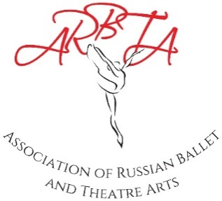

ASSOCIATION OF RUSSIAN BALLET & THEATRE ARTS
(non-profit making organisation)
Patrons: Mikhail Messerer, Olga Sebadoch, Svetlana Adyrkhaeva, Elena Glurjidze

Application Form ARBTA Gala
Dublin – Saturday 24th February 2024
Name of School: |  | Please state whether your school would like to perform in the Gala performance:
Principal’s Name:
ARBTA Membership No (of Principal): |  | How many students would be taking part in the performance? (estimate)
How much time would your school need for their performance? (Up to 10 minutes*) |  | How many separate pieces would be included in your time allocation?
Would you like your pieces separated over the show (to allow for costume changes)? |  | What genres would be included in your pieces?

*Please Note: Schools are allocated up to 10 minutes. This can be divided into different segments/dances and would not have to be performed all at the same time. Schools do not have to use all of the 10 minutes. For example, a school may pick to do 3 separate pieces of 3 minutes each, spread out over the show. Another school may prefer to do 2 dances of 4 minutes consecutively.
We realise these may be rough estimates at this point.
Please email this form to ad.arbta@gmail.com

