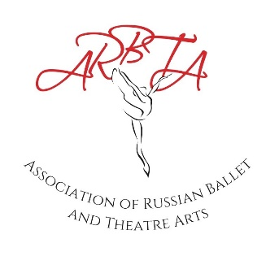

ASSOCIATION OF RUSSIAN BALLET & THEATRE ARTS
(non-profit making organisation)
Patrons: Mikhail Messerer, Olga Sebadoch, Svetlana Adyrkhaeva, Elena Glurjidze

EXAMINATION APPLICATION

Name of School:
Principal:
Membership Number:
Date (Preference 1)
Date (Preference 2)
Date (Preference 3)
Examination Genres:
Major Examinations (Y/N):
Teachers Examinations (Y/N)
Days Required (half/full/numerous):
Estimated Level Range:
Estimated Groups:
Estimated Candidates:
Date Deposit Paid:
Request for Pre-Recorded Examination
(Please state your reason)

All applications should be returned to the administrator at ad.arbta@gmail.com 3 months prior to examinations.
Dates - Please give 3 date options in order of preference. ARBTA will try to book your first option. However, during peak periods, this may not be possible. ARBTA will contact you within 14 days of receipt to confirm the date of your examination session. You will then receive the required documents (Examination Pack) to be completed within the required timeframes.
Estimate - Please understand that these are just estimates. ARBTA does not expect schools to know their complete candidates, groups and levels on application. A basic estimation will help us to secure the correct examiner for your session.
Deposit- Please ensure you have paid your £100 deposit to secure your dates. This must be paid on application via bank transfer to ARBTA – Bank Details: Association of Russian Ballet and Theatre Arts Ltd,
Sort Code: 60-83-71, Account No: 10644254
IBAN – GB41SRLG60837110644254
BIC – SRLGGB2L
Name Followed by Exam Dep

Membership
ARBTA will not be able to process examination applications unless you possess the correct membership.
Office Hours
Tuesday to Friday 9:15 – 12:15. Members can reach the administrator on 07548 818285 during office hours or send an email to ad.arbta@gmail.com.

