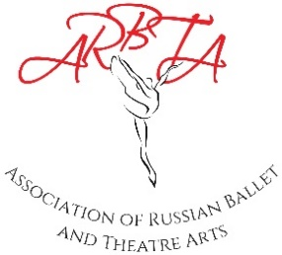

ASSOCIATION OF RUSSIAN BALLET & THEATRE ARTS
(non-profit making organisation)
Patrons: Mikhail Messerer, Olga Sebadoch, Svetlana Adyrkhaeva, Elena Glurjidze

Full Membership and Registration Form

Please complete the form below and send to: ad.arbta@gmail.com

Insert a tick by the membership you are applying for
Full Membership: (Associate/Affiliated/Fellow) | £85
Full Membership: (for those in full time education) | £40
ARBTA Student Membership | £25
*Early Bird Membership (if paid before 1st January) | £75

Name |  | Membership  Number
Address |  | Contact  Number
 |  | Registration Number
Email  Address |  | Name of School

Please return this form along with the following:
- Enhanced DBS Check (or Equivalent) – provide one of the following as evidence
- The Original Certificate (dated within the last two years)
- Permission form to check DBS online via the Government update service
- DBS Information if complete with the DDC.
- Equivalent documentation for members outside of the UK.

DBS (or equivalent) certificate number ………………………………………………………………
- First Aid Certificate
This must be a practical course within the last three years.
- Safeguarding Certificate
Completion of a Level 1 Safeguarding course (an online course is acceptable)
- Attendance at meetings - provide two of the following as evidence
- Verification forms or CPD Certificates
- Dates of Examiner discussion following a session ……………………………

I wish to renew my 2023 Membership and have made an online payment of £................. to ARBTA.
Bank Details: Association of Russian Ballet and Theatre Arts Ltd
Sort Code: 60-83-71 Account No: 10644254 IBAN – GB41SRLG60837110644254 BIC – SRLGGB2L (Name and membership as reference)

I agree to abide by the Rules & Regulations of the Association.

Signed......................................................... Date..........................................

