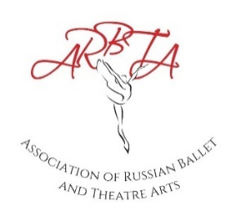
ASSOCIATION OF RUSSIAN BALLET & THEATRE ARTS
EXAMINATION PAYMENT FORM (from January 2023)

The fees below state the basic rate for examinations from January 2023. A
supplement may be applied to the examination fees depending on the location of the examination session and the number of entries.
Name of School:
Date of Examinations:
Ballet and Contemporary Examinations |  |  |  | Jazz, Tap & Character Awards
Level | Amount | Total Candidates  Entered for Level | Total Amount | Level | Amount | Total Candidates  Entered for Level | Total Amount
Preliminary Assessment | £30 |  |  | Assessment Class | £30
Preliminary Examination | £31 |  |  | Preliminary | £36
Grade 1 | £35 |  |  | Junior Bronze | £37
Grade 2 | £36 |  |  | Junior Silver | £38
Grade 3 | £37 |  |  | Junior Gold | £39
Grade 4 | £40 |  |  | Senior Bronze | £40
Grade 5 | £42 |  |  | Senior Silver | £41
Grade 6 | £44 |  |  | Senior Gold | £42
Grade 7 | £46
Grade 8 | £48
Intermediate | £57
Advanced Foundation | £60
Advanced I | £62
Advanced II | £65
 |  | Total  Sum | £ |  |  | Total Sum | £
Total Sum Examinations and Awards |  |  | £

Teachers Examinations (Ballet/Jazz/Tap/Contemporary/Character)
Level |  | Amount | Total Candidates Entered for Level | Total Amount  (Amount x Total Candidates)
Associate - All 4 Modules |  | £360
Associate - Singular Module |  | £100
Diploma - All 4 Module |  | £370
Diploma - Singular Module |  | £100
Advanced - All Modules |  | £235
 |  |  | Total Sum Teachers Exams | £
Complete Sum – Total Sum of Examinations, Awards and Teachers Examinations |  |  |  | £
Complete Sum – Total Sum of Examinations, Awards and Teachers Examinations minus £100 deposit |  |  |  | £
Payment Date:
Please pay the Complete Sum via bank transfer to ARBTA – Ref: Exams and School Name.
Bank Details: Association of Russian Ballet and Theatre Arts Ltd,
Sort Code: 60-83-71 Account No: 10644254
IBAN – GB41SRLG60837110644254 BIC – SRLGGB2L

