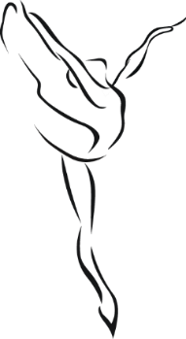
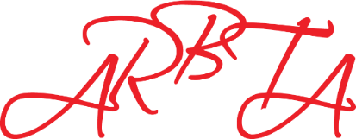

Association of Russian Ballet & Theatre Arts

Venue: Dublin Ballet Academy
40 Drumcondra Road Lower
Drumcondra
Dublin 9
Ireland
DO9 V5R9

Dublin
Seminars
24th and 25th February 2024

24th February 2024 25th February 2024
10:00 | Ballet Masterclass (Jnr) | 10:00 | Character Masterclass
11:15  12:30  13:45  15:00  16:15 | Ballet Repertoire Workshop (Jnr)  Ballet Masterclass (Snr)  Ballet Repertoire Workshop – (Snr)  Indian Dance Workshop (All)  Finish | 11:15  12:30  13:45  15:00  16:15 | Contemporary Ballet Class  Ballet Masterclass: Allegro Focus  Contemporary Workshop  Indian Dance Workshop  Finish
Information
Each workshop will last 1 ¼ hrs. Junior Level classes are recommended for students under the age of 12 with dance experience. Senior Level class are recommended for student over the age of 13.
On Sunday 25th February, there will also be Q & A Teachers Sessions running at the same time as the workshops where you will be able to ask examiners any syllabus or examination questions. These are relaxed sessions in small groups, but please state the subject and time you would prefer on the booking form so an examiner may be allocated. Teachers may also watch or join in the workshops, but there are limited spaces so please return your booking form as soon as possible.

The Q and A sessions are free for ARBTA member teachers and €25 per session for non-members. The Dance Workshops will cost €20 each or €30 for 2 workshops. Places are limited so please register your interest as soon as possible.
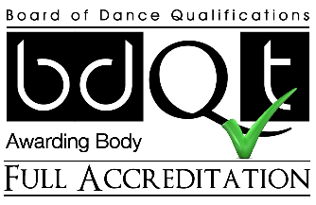
Since 2016, ARBTA has been distributing Attendance Certificates at its seminars and workshops as proof of your CPD (Continuing Professional Development). This is a requirement of ARBTA, GQAL and the BDQT. Teachers and student teachers must attend at least one ARBTA training day per year.
Please email ad.arbta@gmail.com to register or for further information.

