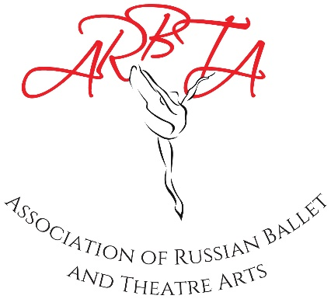

ASSOCIATION OF RUSSIAN BALLET & THEATRE ARTS
(non-profit making organisation)
Patrons: Mikhail Messerer, Olga Sebadoch, Svetlana Adyrkhaeva, Elena Glurjidze

Examination Entry Form
Timetable

Name of School: |  | Address of School (Address examination session is to be held):
Principal’s Name:
ARBTA Membership No: |  | Address of Teacher (Address examination results and certificates will be sent):
Contact Telephone No:
Email Address: |  | Examiner:
Date of Exam: |  | Examiners Email:
Travel Details: (By road or rail for examiners)

All teachers involved in the preparation of candidates and guiding though the examination. Please ensure the teachers number below corresponds with the ‘Teachers Number’ column on the timetable.
Teacher No: | Name: | Membership No:
1
2
3
4
5

ASSOCIATION OF RUSSIAN BALLET & THEATRE ARTS

Examination Entry Form & Timetable
Name of School: |  | Examination Date:
Principal: |  | Membership No:

Time | Level | Group | Candidate  Number | Name | Age | Mark | Result | Teachers  Number

