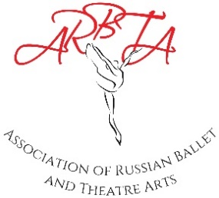

ASSOCIATION OF RUSSIAN BALLET & THEATRE ARTS
(non-profit making organisation)
Patrons: Mikhail Messerer, Olga Sebadoch, Svetlana Adyrkhaeva, Elena Glurjidze

Interim Membership and Registration Form

Please complete the form below and send to: ad.arbta@gmail.com

Insert a tick by the membership you are applying for
Full Membership: (Associate/Affiliated/Fellow)- Interim Years Only | £85
Full Membership: (For those in full time education)- Interim Years Only | £40
ARBTA Student Membership – Interim Years Only | £25
*Early Bird Membership (If paid before 1st January) – Interim years Only | £75
Retainer Membership | £10
Friends of ARBTA Membership | £10

Name |  | Membership  Number
Address |  | Contact  Number
 |  | Registration Number
Email  Address |  | Name of School

I wish to renew my 2023 Membership and have made an online payment of £................. to ARBTA.
Bank Details: Association of Russian Ballet and Theatre Arts Ltd
Sort Code: 60-83-71 Account No: 10644254 IBAN – GB41SRLG60837110644254 BIC – SRLGGB2L (Name and membership as reference)

I agree to abide by the Rules & Regulations of the Association.

Signed......................................................... Date..........................................

