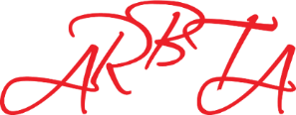
ASSOCIATION OF RUSSIAN BALLET & THEATRE ARTS
(non-profit making organisation)
Patrons: Mikhail Messerer, Olga Sebadoch, Svetlana Adyrkhaeva, Elena Glurjidze

Centre Policy, Procedures and Licence Checklist

Please indicate, by ticking the appropriate boxes that you have the following Policies, Procedures, and Licences in place.
Health & Safety
First Aid Kit

Accident Book

Evacuation procedures

Fire Safety Management Policy

Health & Safety Policy

Risk Assessment & Management Policy

Safeguarding, Child Protection & Suitability of Staff
Safeguarding & Child protection Policy

DBS Checks for staff & volunteers
Designated Safeguard Lead (DSL)

Governance
GDPR Compliant

Student Registration Form

Student Records & Registers

School Prospectus & Rule Book

Music Licences (PRS/PPL)

Additional Policies & Procedures
Complaints Procedure/Policy

Equal Opportunities Policy

Employers Insurance

Public Liability Insurance

Whistle Blowing Policy

