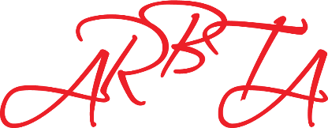
REMOTE EXAMINATION SESSION
REQUEST FORM

Centre Name:
Centre Address:
Preferred Date of Remote Session:
Reason for Request:
Preferred Remote Option:

DECLARATION

PLEASE TICK THE BOXES BELOW
☐ I confirm that I have read and understood the REMOTE EXAMINING document (Appendix 1).
In particular I will ensure:
☐ The camera operator is familiar with dance.
☐ The footage will be visually and audibly clear.
☐ Where requested a second video or live stream panning the whole studio.
☐ The recording is not paused for any reason.
☐ The camera will not be left unattended and only turned off during scheduled breaks.
☐ The video footage will be transferred immediately after the examination to Head Office and a copy kept on a secure device.
☐ The copy of the recording will be deleted after the candidates have received their certificates.
☐ Video footage transmitted digitally after the examination will be done via a secure platform
☐ That the video footage will not be shared, transferred or shown to any other person or organisation.
☐ A ‘Remote Examining Consent Form’ will be completed by all candidates (by the parent/guardian for children under 18 or in the case of a vulnerable adult).
☐ A confirmation that all candidates entered have signed the consent form and understand copies may be requested.
☐ I confirm that I have read and understood the GUIDANCE FOR VIDEO RECORDING (Appendix 2)
☐ I confirm that I have read and understood the ABSENCE OF THE EXAMINER (Appendix 3)

Name …………………………………………………..

Signature …………………………………………………..

Date …………………………………………………..

