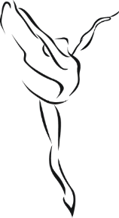
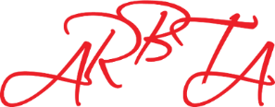
ASSOCIATION OF RUSSIAN BALLET & THEATRE ARTS
(non-profit making organisation)
Patrons: Mikhail Messerer, Olga Sebadoch, Svetlana Adyrkhaeva, Elena Glurjidze

APPLICATION FOR REASONABLE ADJUSTMENTS

Please complete and return this form, along with current medical/psychological evidence from a competent person to support the application, each time a candidate is entered for an ARBTA Qualification for which Reasonable Adjustments are being sought (separate forms are required for each Qualification entry).
Please be advised that the candidate’s performance will still be assessed against the required standard for the assessment as we are unable to make any allowances in this respect.
The form should be returned to Head Office 12 weeks prior to the date of the assessment.

Centre Name and Code:
Candidates Name:

Examination/Assessment:
Grade/Level

Discipline
Proposed date of Assessment

Please complete either box A or box B (using additional sheets if necessary)
Box A – Where no changes to the examination conditions are required but you require the examiner/assessor to be aware of the candidate’s difficulties and how this may affect them in the assessment:
Please give details of the candidate difficulties and how this may affect them in the examination.

Box B – Where you want us to make changes to the assessment conditions:
Please give details of the candidate difficulties and the requested changes.

Declaration
I am satisfied that the information provided is accurate:
Name: | Signature:
You will receive a response within 10 working days from date of receipt.

