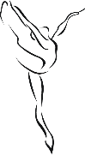
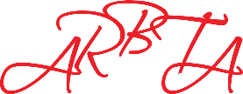
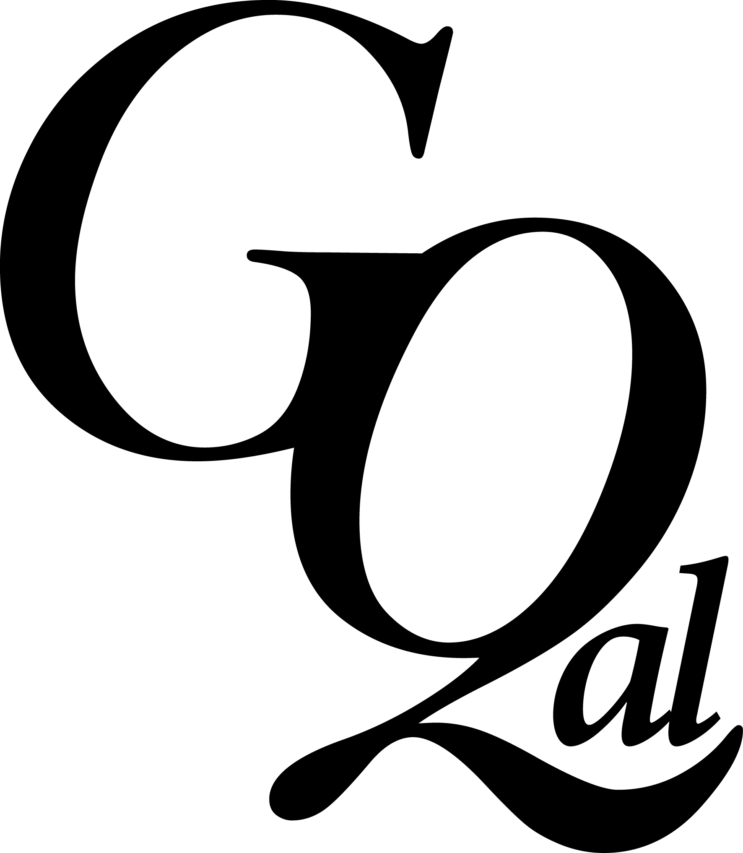
Candidate Registration Form
Filming Consent Form
For ARBTA Examinations and Assessments
Centre Registration Number:
Centre Post Code:
Centre Name:

Family/Surname |  |  | Ethnicity  Please tick box next to one of the following
Forename (s) |  |  | Bangladeshi
 |  |  | Indian
Gender |  |  | Pakistani
 |  |  | Any other Asian Background
Nationality |  |  | African
 |  |  | Caribbean
Email Address |  |  | Any other Black Background
 |  |  | Chinese
Telephone Number |  |  | White and Asian
 |  |  | White and Black African
Date of Birth |  |  | White and Black Caribbean
 |  |  | Any other Mixed Background
ULN Number |  |  | White British
 |  |  | White Irish
Address Line 1 |  |  | Any other White Background
Address Line 2 |  |  | Any other Ethnic Group
Town |  |  | White Not Known
City |  |  | Refuse To Say
Postcode
Country

In accordance with our policies, ARBTA will not permit photographs, videos or images to be used without consent. By completing this form, you are agreeing that the examination involving you or your child (on the date, time and location below), will be filmed. A parent or guardian should sign the form for candidates under the age of 18.
Consent is given by signing the form below. Consent may be withdrawn at any time if requested. The data provided on this form will be stored in a computerised database in compliance with the Data Protection Act. Information you provide on this enrolment will be passed to the Learning Records Service, Learning Skills council and Regulatory Authorities which are registered under the Data Protection Act. The information will not be given to anybody outside of ARBTA or GQAL without your permission except if required to do so by law or examination regulatory agencies. Access to the information is strictly limited to ARBTA staff who process the examination entry and the ARBTA Board of Examiners.
For archiving and training purposes ARBTA reserves the right to video record examinations.
Name: | Parent/Guardian Name:
Date of Exam: | Teachers Name:
Exam Level: | Signature:
Declaration: By completing and signing this form, I confirm that the information is accurate and give consent for filmed footage to be taken and used as stated on this form. For forms received electronically, a typed name will be taken as a signature.

